Name: Preksha Jain

SAP: 500120166

Batch: 1

**EXPERIMENT 10 and 11**

Experiment 10:

**Title: Create the following views in SQL on the COMPANY database schema presented in Experiment 2.**

1. A view that has the department name, manager name, and manager salary for every department.

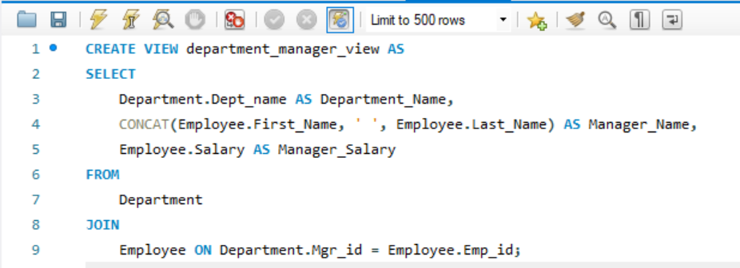

1. A view that has the employee name, supervisor name, and employee salary for each employee who works in the ‘Research’ department.

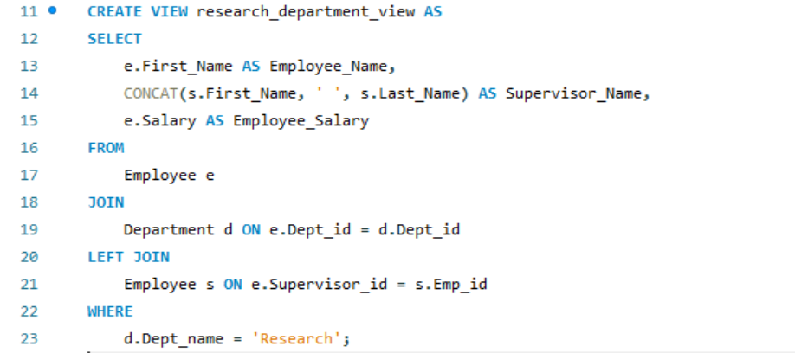

1. A view that has the project name, controlling department name, number of employees, and total hours worked per week on the project for each project.

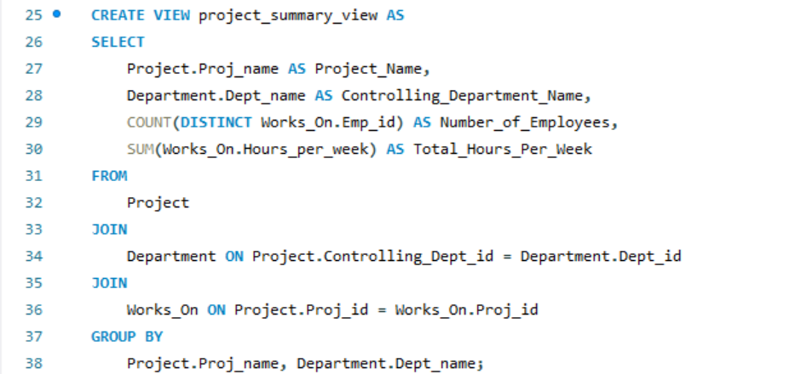

1. A view that has the project name, controlling department name, number of employees, and total hours worked per week on the project for each project with more than one employee working on it.

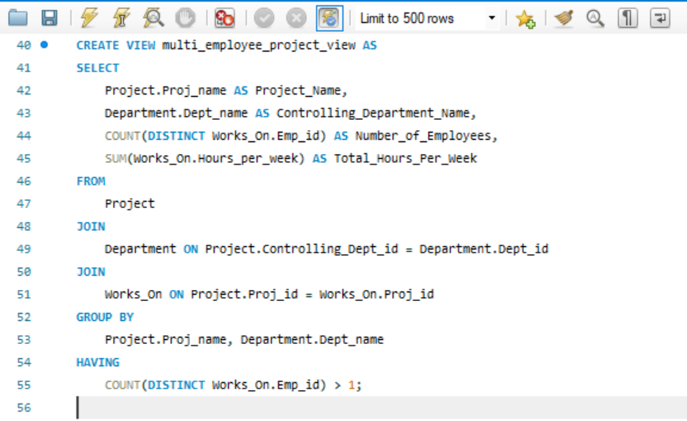

EXPERIMENT 11:

**Title: To understand the concepts of Index.**

**Objective:** Students will be able to implement the concept of index.

**Create table of table name: EMPLOYEES and add 6 rows**

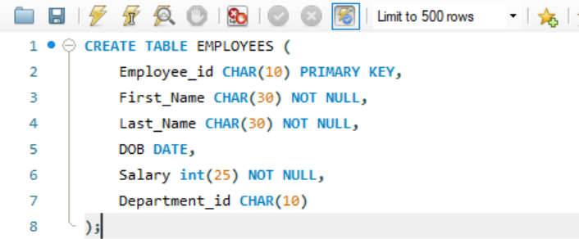

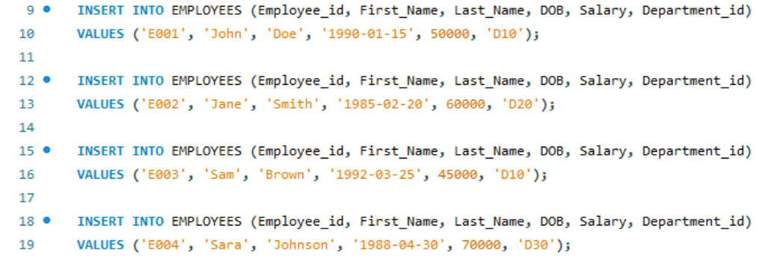

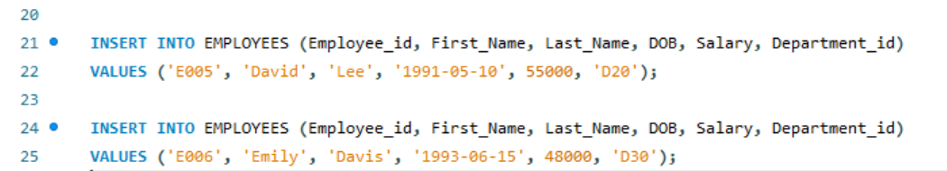

**1. Execute the following index related queries:**

1. Create an index of name employee_idx on EMPLOYEES with column Last_Name, Department_id

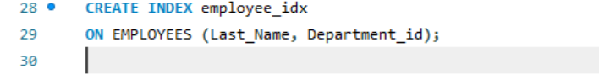

1. Find the ROWID for the above table and create a unique index on employee_id column of the EMPLOYEES.

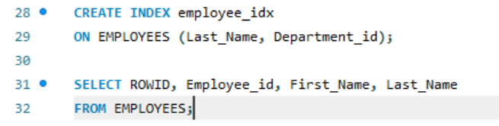

1. Create a reverse index on employee_id column of the EMPLOYEES

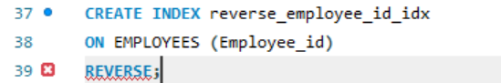

1. Create a unique and composite index on employee_id and check whether there is duplicity of tuples or not.

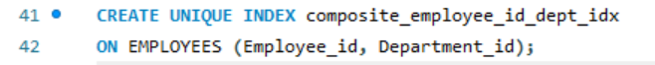

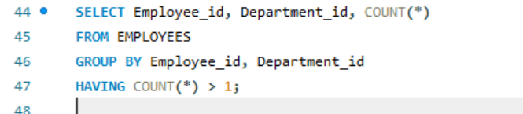

1. Create Function-based indexes defined on the SQL functions UPPER(column_name) or LOWER(column_name) to facilitate case-insensitive searches(on column Last_Name).

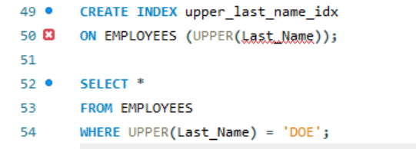

1. Drop the function based index on column Last_Name.

